Table of Contents

Chapter 1 1

1. Introduction 1

1.1 Introduction to E-Commerce 1

1.2 Introduction to MIS 2

1.2.1 Management 2

1.2.2 Information 2

1.3 Introduction to Store 3

Chapter 2 4

2. Planning 4

2.1 Introduction to Planning 4

2.2 The E-commerce planning process 4

2.3 Budget 4

2.4 Gantt Chart 5

Chapter 3 6

3. Network Infrastructure 6

3.1 Introduction to Network Infrastructure 6

3.1.1 Connecting to the Internet 6

Chapter 4 7

4. Process of website Building 7

4.1 Website Building 7

4.1.1 For Hosting and Domain 7

4.1.2 Customer Account 7

4.1.3 Admin Dashboard Login 7

Chapter 5 8

5. Payment Gateway 8

5.1 Payment Gateway in E-commerce 8

Chapter 6 9

6. Screen Capture 9

6.1 Customer Account Register and login 9

6.2 Home Page 10

6.3 Add Cart 10

6.4 Admin Dashboard 11

6.5 WooCommerce Add Product 11

6.6 WooCommerce Order 12

Chapter 7 13

7. Conclusion 13

7.1 Conclusion of Project 13

# Chapter 1

## 1. Introduction

## 1.1 Introduction to E-Commerce

E-commerce refers to the buying and selling of goods and services over the internet, utilizing electronic transactions and digital technologies. This shift from traditional brick-and-mortar stores to online platforms has revolutionized the global marketplace in numerous ways.

E-commerce offers several advantages, both for businesses and consumers. For businesses, it provides a broader reach, allowing them to target customers beyond geographical limitations. It also lowers operational costs as there's no need for physical storefronts and reduces the barriers to entry for small businesses. On the consumer side, e-commerce provides convenience, enabling shoppers to browse and purchase products from the comfort of their homes, anytime and anywhere. Additionally, it offers a wider selection of products and services, often at competitive prices.

The history of e-commerce can be traced back to the 1960s with the development of electronic data interchange (EDI), which allowed businesses to exchange documents electronically. However, it wasn't until the 1990s with the emergence of the internet and the World Wide Web that e-commerce began to gain widespread popularity. Companies like Amazon and eBay played pivotal roles in shaping the e-commerce landscape, demonstrating the viability and potential of online shopping.

Today, e-commerce encompasses a wide range of activities, including online retail, digital marketplaces, online auctions, and business-to-business transactions. It continues to evolve with advancements in technology, such as mobile commerce (m-commerce), social commerce, and the integration of artificial intelligence and machine learning to enhance the shopping experience.

Some common types of E-commerce:

* Business-to-Consumer (B2C)
* Business-to-Business (B2B)
* Consumer-to-Consumer (C2C)
* Consumer-to-Business (C2B)

## 1.2 Introduction to MIS

Management Information Systems (MIS) are the backbone of modern organizations, providing the infrastructure and tools necessary to collect, process, and analyses data for effective decision-making. At its core, MIS involves the systematic management of information resources, encompassing data collection, storage, processing, and dissemination. Through MIS, organizations can streamline their operations, improve efficiency, and gain a competitive edge in the marketplace.

## 1.2.1 Management

Management covers the planning, control, and administration of the operations of a concern. The top management handles planning; the middle management concentrates of controlling; and the lower management is concerned with actual administration.

## 1.2.2 Information

Information, in MIS, means the processed data that helps management in planning, controlling and operations data means all the facts arising out the operations of the concern. Data is processed i.e., recorded, summarized, compared and finally presented to the management in the form of MIS report.

**1.2.3** System

Data is processed into information with the help of a system. A system is made up of inputs, processing, output and feedback or control.

Thus, MIS means a system for processing data in order to give proper information to the management for performing its functions.

The major components of a typical MIS long-form (Management Information System) are:

**People:** People who use the information system.

**Data:** The data that the information system records.

**Business Procedures:** Procedures put in place on how to record, store and analyzed data.

**Hardware:** These includes servers, workstations, networking equipment, printers, etc.

**Software:** These are programs used to handle the data. These include programs such as spreadsheet programs, database software, etc.

## 1.3 Introduction to Store

E-commerce online shopping has become popular business and had increased rate in business sector. It’s has made rapid competitions among them. Online Store is one of them that is located in Butwal, Drivertol. There are stands which provides some kinds of clothes products and shoes. The owner of Online Store is said that to his business, he still used paper-based system.

List of products are available form Online Store are as follows:

* Shirt
* T-Shirt
* Shoes
* Pants

One of the weaknesses when doing such a system is the calculation of money which is done manually and the end process of calculation is to know the income. if we use paper-based, it will spend much time. Therefore, it can give disadvantages in many cases. Paper-based system will make difficult the worker when giving services toward their customer or guests.

# Chapter 2

## Planning

## Introduction to Planning

Planning is deciding in advance what to do, how to do it, when to do it, and who should do it. This bridges the gap from where the organization is to where it wants to be. The planning function involves establishing goals and arranging them in logical order.

## The E-commerce planning process

The e-commerce planning process has 6 key steps to get you up and running with e-commerce. It’s covers the key skills, system and sales know-how you need to drive e-commerce success.

1. **Identify the opportunity:** The first step of the e-commerce planning process is to identify the opportunity. What benefit is e-commerce actually going to have for yours target audience and your brand? What e-commerce insights do you have that make you confident you’ll make money selling online? You need to spend time defining the opportunity more specifically than just “sell online” That’s too broad. The move to sell online is similar to decision to lunch a new product.
2. **Validate the opportunity:** So, once you’ve identified the opportunity, need to test out if it is big enough to be worth pursuing. There’s no single best way to do this. It very much depends on the size and nature of the opportunity. And your approach to opportunities and risk.
3. **Channel planning:** Once you’ve identified and validated the overall e-commerce planning opportunity for your business, it’s now time to think about where you will sell online.
4. **Develop experiences:** This is where are a series of steps consumer go through before they become loyal and regular purchasers. So, they need to trust your brand, be aware of your brand, be persuaded to consider it so on.
5. **Sell:** Once you have all these elements of the e-commerce planning process lined up, then your focus moves on to how to continue to sell your products online.
6. **Evaluate and optimize:** To setting up an online retailers and store, we expand more on the day-to-day operations of online selling once you’ve gone through the e-commerce planning process. On-going, it’s important to think like a retailer.

## Budget

|  |  |  |  |
| --- | --- | --- | --- |
| **S. N** | **Name** | **Pricing** | **Duration** |
| 1. | Free Sub-Domain (pantheonsite.io) | Free | Life Time |
| 2. | Pantheon Hosting | Free | Life Time |
| 3. | Maintenance | Free | 5 to 10 Minutes |

Table 1: Budget

## Gantt Chart

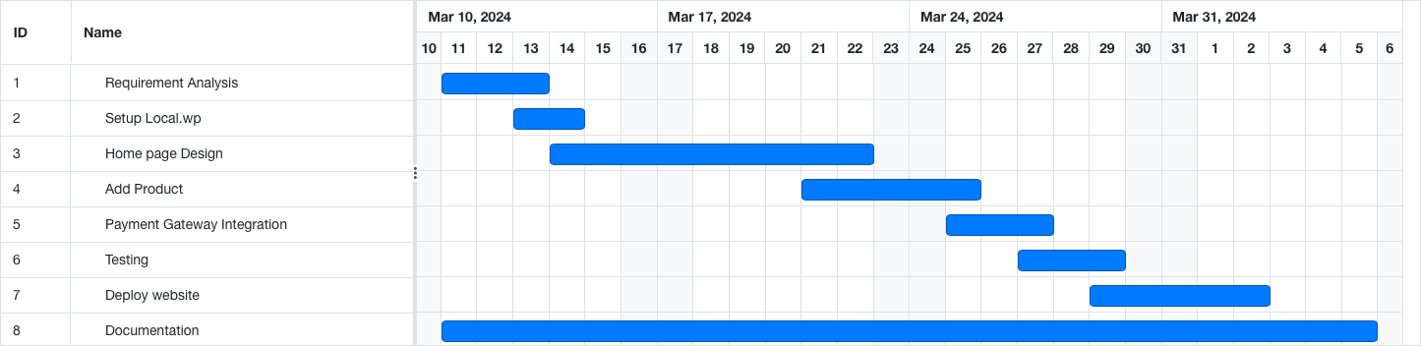

Fig 1: Gantt Chart

Chapter 3

## Network Infrastructure

## Introduction to Network Infrastructure

Network infrastructure is required for e-commerce to transport content. I-way is a high-capacity, interactive electronic pipeline used to transfer content in case of ecommerce. I-way can transfer any type of context like, text, graphics, audio, video. In other words, multimedia contents are easily transported through I-way.

A network can be defined as: -

* Building block of E-commerce.
* Technologies to integrate Business Process
* Mediator for Digital transmission of Digital
* Content/Message/File/DATA
* The interaction between Entities of business
* like Supplier/Distributor/partner etc.
* A framework with security & ease.

## Connecting to the Internet

1. Dial-up Connection: Computers that are serving only as clients need not be connected to the internet permanently. Computers connected to the internet via a dial-up connection usually are assigned a dynamic IP address by their ISP (Internet Service Provider).
2. Leased Line Connection: Servers must always be connected to the internet. No dial-up connection via modem is used, but a leased line. Costs vary depending on bandwidth, distance and supplementary services. In these Given Network of Internet easily to use and able to any issues will be found while running the website.

* WPA
* 3G
* 4G
* 5G

3.1.2 Components of I-way

1. **Consumer access equipment:** Consumer access equipment are devices used by consumers to access the multimedia interactive contents of e-commerce. In this segment, hardware and software vendors are also included.
2. **Local on-ramps:** This segment of I-way simplify linkages between businesses, universities, and homes to the communications backbone. There are four different types of providers of access ramps: - telecom based - cable TV-based - wireless-based and - computer-based online information services. These providers link users and e-commerce application providers.
3. **Global information distribution networks:** Global information distribution networks are the infrastructure that is connecting countries and continents.

# Chapter 4

## Process of Website Building

## Website Building

This is e-commerce website is a single vendor website, which is make a word press CMS platform.

Some step of the procedure of website building are as follow:

1. First, we install local. wp on my laptop and create your local word press site.
2. We install Botiga theme from word press theme and activates its.
3. We install all the required plugins and activates all plugins.
4. Customize the design of website pages.
5. Now install payment gateway plugins like esewa, khalti for get payment.
6. Add Products in WooCommerce production section.
7. Finally, all complete the section of website live on laptop.

## For Hosting and Domain

1. We registered domain
2. Buy web hosting
3. Migrate the file of website having in local. wp to web hosting
4. From using migration file tools
5. Then complete the procedure

## Customer Account

1. Customer can register an account from URL domain name/my-account

## Admin Dashboard Login

1. Administrator can able to login follow the web URL domain name/wp-admin

# Chapter 5

## Payment Gateway

## Payment Gateway in E-commerce

A payment gateway authorizes the transfer of funds between buyers and sellers. It allows your e-commerce site to request money from a customer's bank for products or services that they have purchased. Assuming it is approved, the payment is then securely transferred to your bank or wallet.

In our e-commerce website have different modes of payment. Some of the Popular modes of payments system are as:

* E-Sewa
* Khalti
* Debit Card
* Cash on delivery

In our website we are include E-Sewa and Cash on delivery for payments method and it is client user friendly for payment complete process.

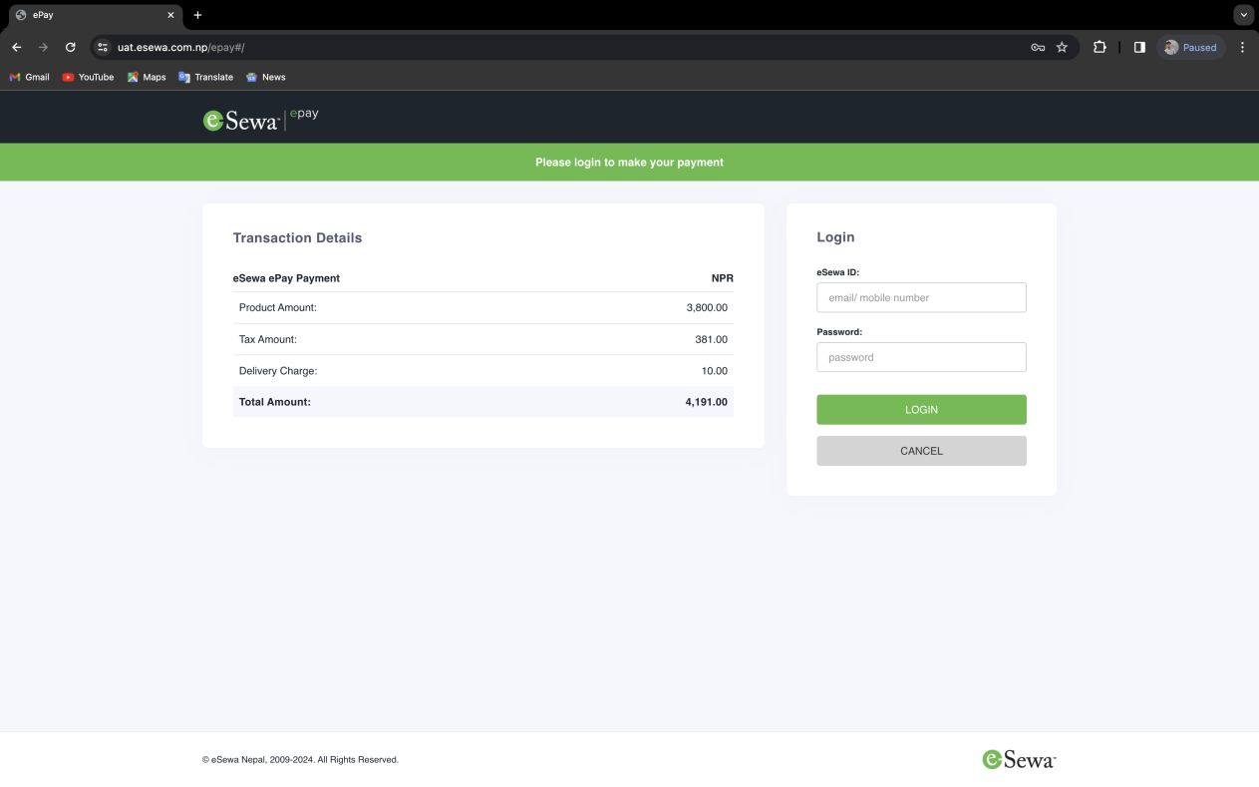

Fig 2: E-sewa Payment Gateway

# Chapter 6

## Screen Capture

## Customer Account Register and Login

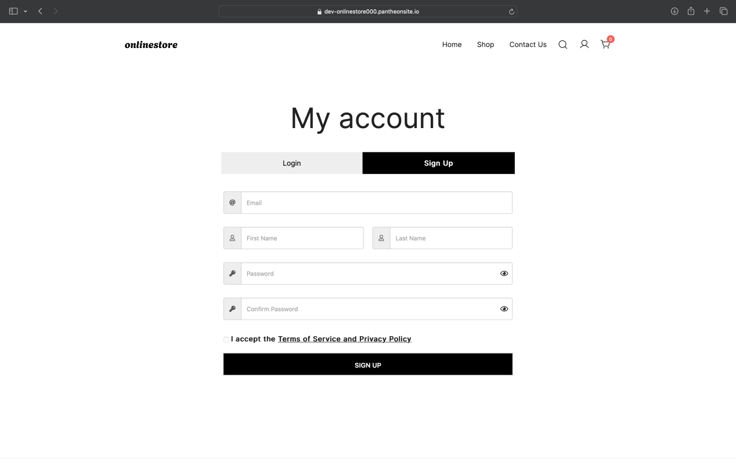

Fig 3: Register

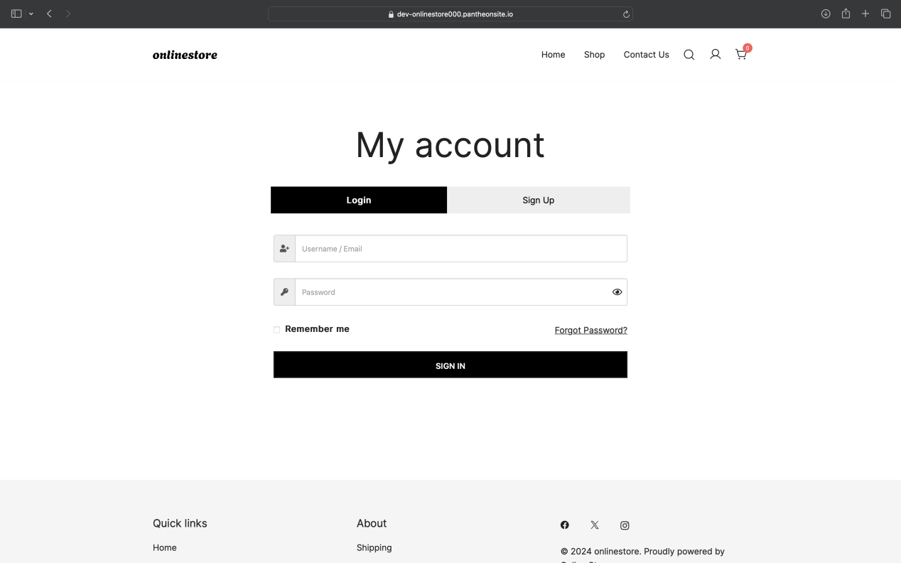

Fig 4: Login

## Home Page

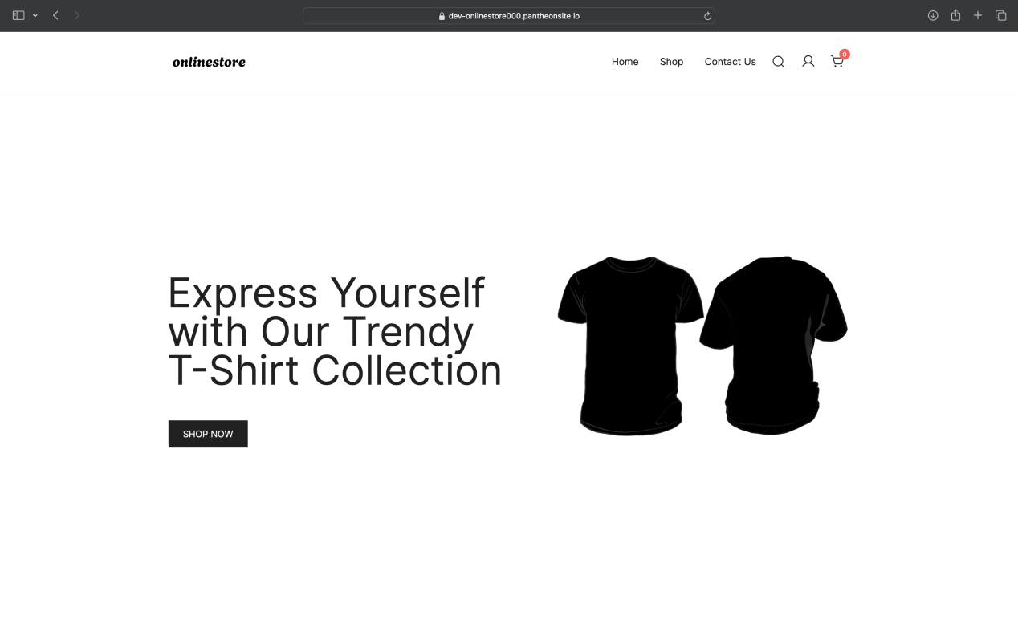

Fig 6: Home Page

## Add Cart

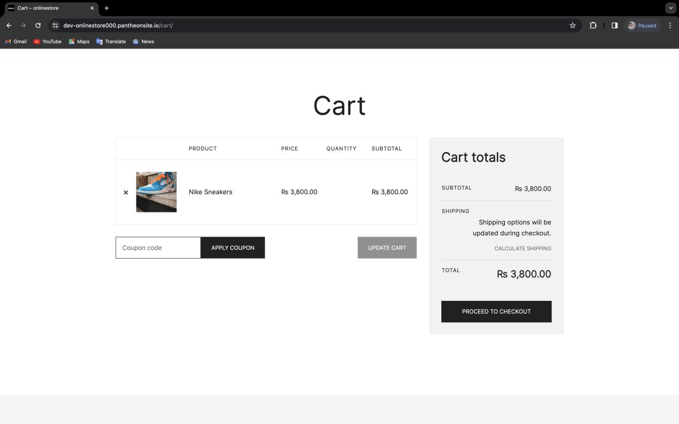

Fig 6: Cart

## Admin Dashboard

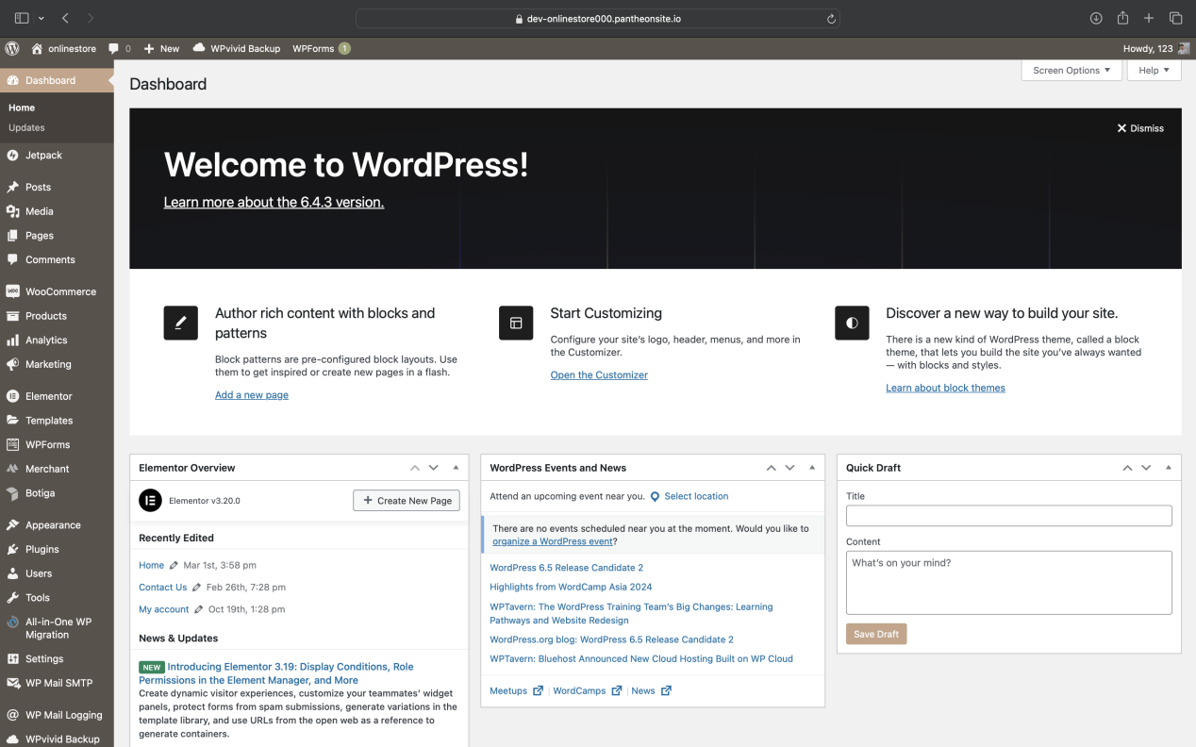

Fig 7: Admin Dashboard

## WooCommerce Add Product

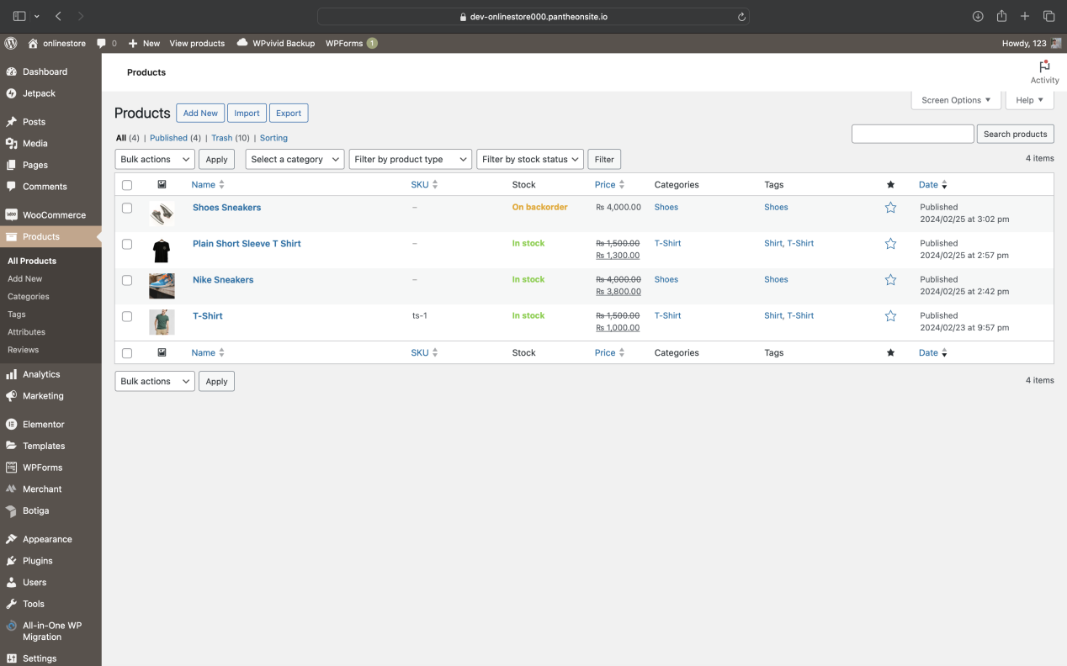

Fig 8: Add Product

## WooCommerce Order

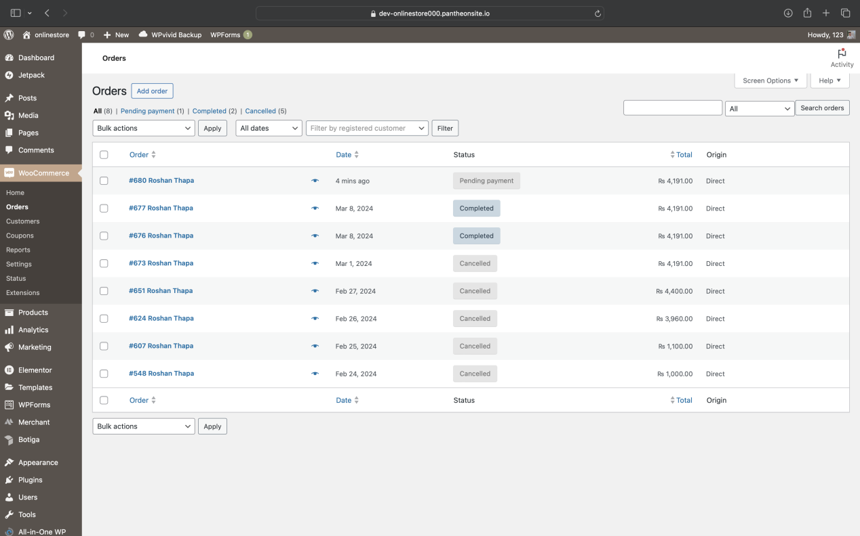

Fig 9: Order

# Chapter 7

## Conclusion

## Conclusion of Project

Creating an e-commerce website with WordPress is a straightforward process. With the right plan, domain name, hosting service, and theme selection, you can have a fully functional online store in no time.

This project has a user side where anyone can view product category and add product to cart and proceed for checkout and the payment gateway and also available cash on delivery system. Admin side where admin can view product order, number of products, users, and add product and categories.

The user can also leave comments on each product if user wants. In this project, all the main functions are performed from the admin side user friendly.